GIS 17th of May
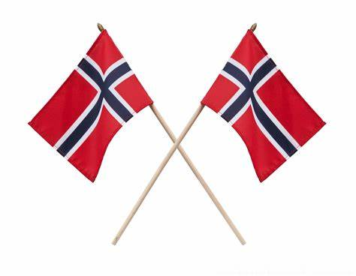
HURRAY! We are finally able to celebrate together as a GIS Community and we encourage everyone to join us
the 17th of May
10.00: The Parade
All students meet at Gjøvik Stadium no later than 09.45: find the school banner (almost last, in front of Gjøvik Videregående). Please bring your flags and wear comfortable shoes
The parade ends at Gjøvik Gård. There is usually a lot of people in Gjøvik Gård and it is difficult to ensure effective supervision for large groups. This year we will arrange a pickup-point behind Gjøvikhallen, we will go there directly after entering Gjøvik Gård. Students need to be picked up by parents there as soon as they arrive. Mr Armanski will send you more details about the meeting place in this weeks Newsletter.
Please be there in time and make sure to let GIS staff know when you pick up your child.
The students from a local school have prepared a short program and everyone is encouraged to stay and listen.

13.30 – 16.00: Celebration at GIS
We are very pleased to welcome everyone to a gathering at GIS. The celebration will take place on the footballfield outside the school. Please bring your own lawn chairs (and tables should you wish to). There will be arranged traditional games for the children (and anyone else).
There will be a café selling cake, icecream, hotdogs, juice (saft), coffee and tea. We would love it if you pay by Vipps! If you are not able to, please bring coins for your buying. Thank you!

It would be very helpful if we all make sure to throw our own used cups and napkins after use. There will be big plastic bags marked with «paper» and «restavfall». Thank you!

Welcome!
